
Assignment 2: BOOSE DRAWING APPLICATION
Project Documentation
Advanced Software Engineering

By: Ayesha Gautam - 77466813(L6 Group-D)

Table of Content
INTRODUCTION 3
Project Extension Overview 3
Enhanced Features Implemented 3
Variable System Implementation 3
Array Data Structure Support 3
Control Structure Integration 3
Method and Function System 4
Expression Evaluation 4
Improved Command Processing 4
ASSESSMENT REQUIREMENTS 5
File commit evidence 5
Testing files for variable, loop and methods. 5
Documentation with XML comments 7

INTRODUCTION

Project Extension Overview
The BOOSE Drawing Application has gone from its very basics in integrating an entire programming language functionality set. From the development as a command line-based graphic application, it has grown to become a full-fledged graphic programming environment that holds the capacity for its Users to develop their programming applications with variable, array, control structure, and the definition of personal methods that manipulate graphics representations. The enhancements make BOOSE Drawing Application capable of providing a programming interface for its Users to interpret whole programming applications conveyed as algorithms and to run them as command applications for generating complex graphic representations.

Enhanced Features Implemented

Variable System Implementation
The software can now perform mathematical expressions on integer and real number variables. Variables can now be defined and applied to mathematical expressions to create graphing expressions. The software can now handle variable storage and conversions between integer and decimal values with appropriate variable scope levels.

Array Data Structure Support
Single-dimensional arrays have been developed with the capability to support either integers or real numbers. Array operations for storage via the POKE function and recall through the PEEK function have also been provided.

Control Structure Integration
Three kinds of control structures have been provided to allow for complex program logic:
- Conditional Statements: IF-ELSE constructs which evaluate the comparison expressions to select which block of code is executed.
- Loops: loops are iterative structures that allow repeated execution of code blocks during the time a condition remains true. It inherently includes a maximum number of iterations.
- FOR Loops: Counter-based iteration, auto-increment of variable with step value support.

Method and Function System
Users can create user-defined methods with parameters and return values. Methods can be parameterized as well as parameter less. Methods can consist of any legal programming statements (including any other control statements) and take care of the scope of the local variables independently from the global variables.

Expression Evaluation
A mathematical expression parser evaluates arithmetic expressions comprising variables, constants, and operators. The evaluator will have operator precedence implemented, variable substitution, and will be able to automatically perform type conversions between integers and real numbers in its calculations.

Improved Command Processing
The command processing system has now been expanded to support variable substitution in drawing commands, the execution of control statements, the invocation of user methods, and the control of program flow. The system keeps track of the execution status over several lines.

ASSESSMENT REQUIREMENTS

File commit evidence
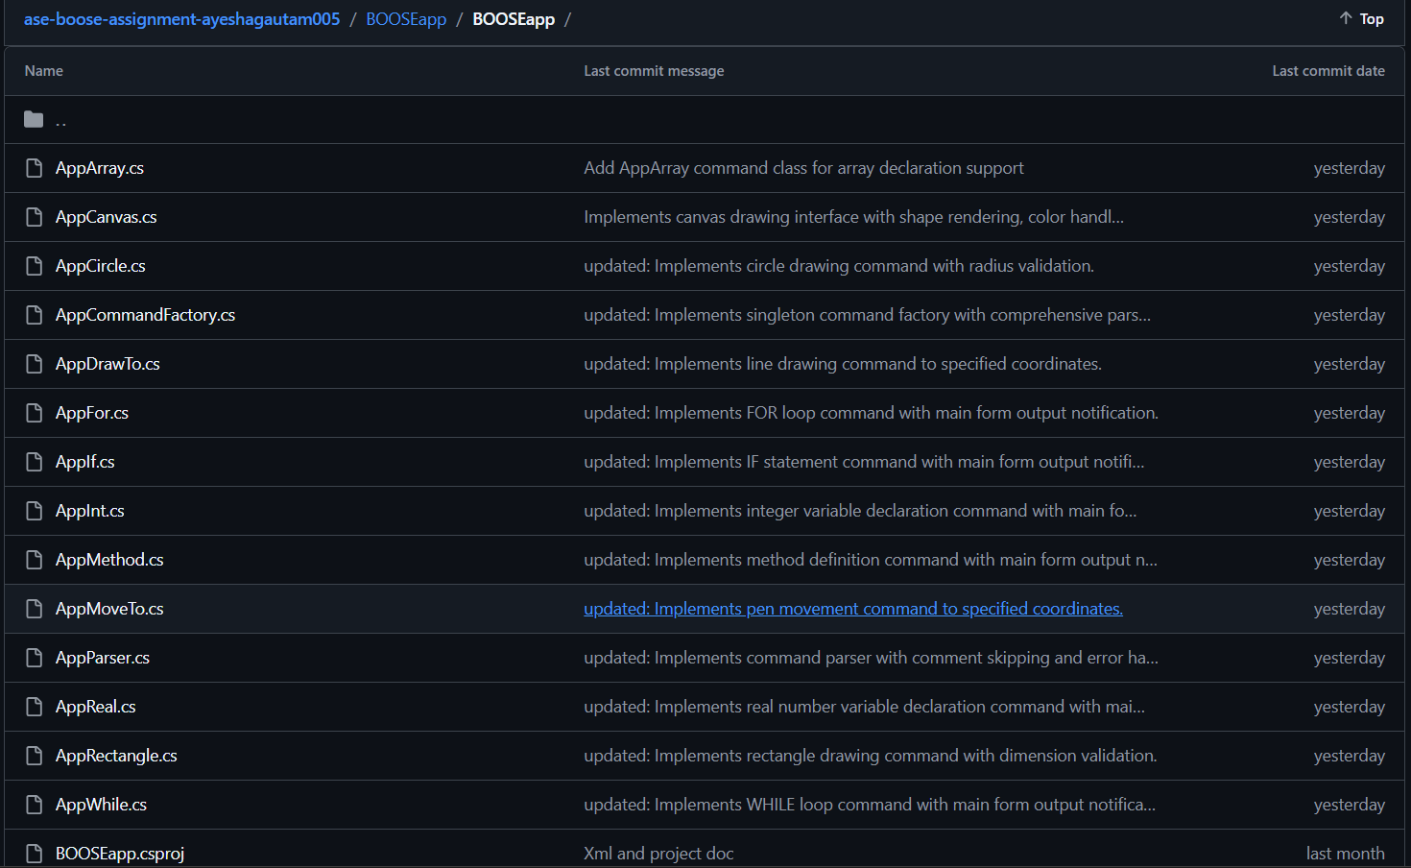
This is just a quick snapshot of the recent commits in my project. Essentially, it just involved the implementation of a number of the basic features in the drawing application.

Testing files for variable, loop and methods.

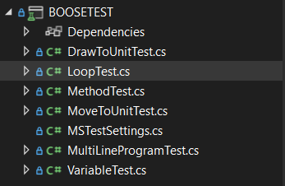
I have created three classes in my drawing application related to testing my scripting engine using unit testing in C#. The VariableTest class ensures that variables and arrays will be stored and accessed correctly. The LoopTest class verifies that while and for loops will execute for the proper number of iterations and if else statements will function correctly. Finally, there is MethodTest, where I have ensured proper functioning related to my system for creating custom methods.
Tests passed:
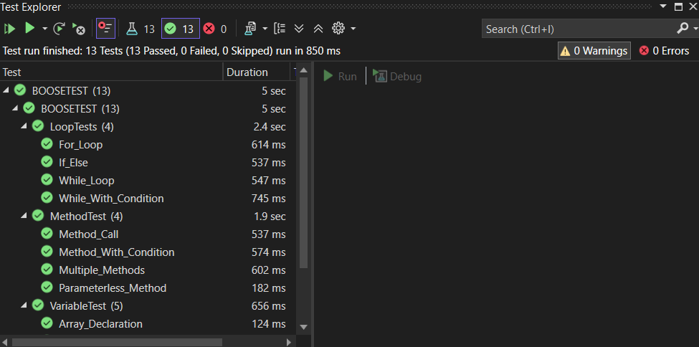
This screenshot shows all 16-unit tests ran successfully.
Tests failed:
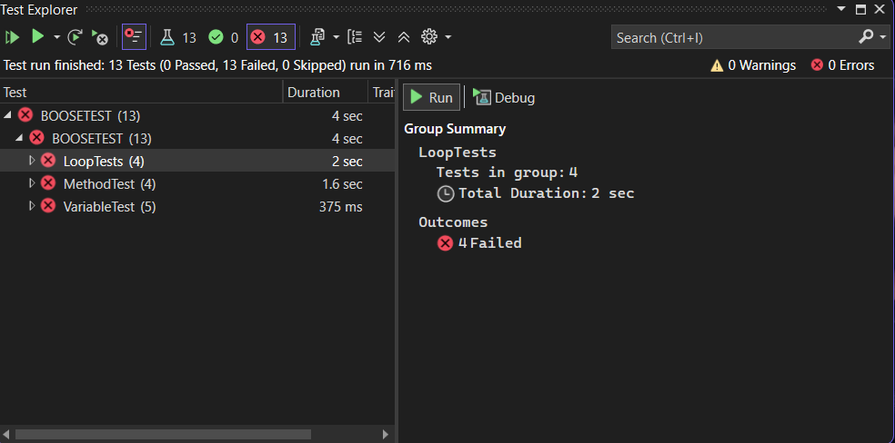
This screenshot shows all 16-unit tests failed.

Documentation with XML comments

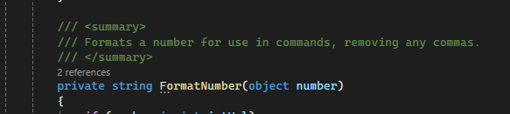
The screenshot shows a method from the codebase with a clear XML comment.
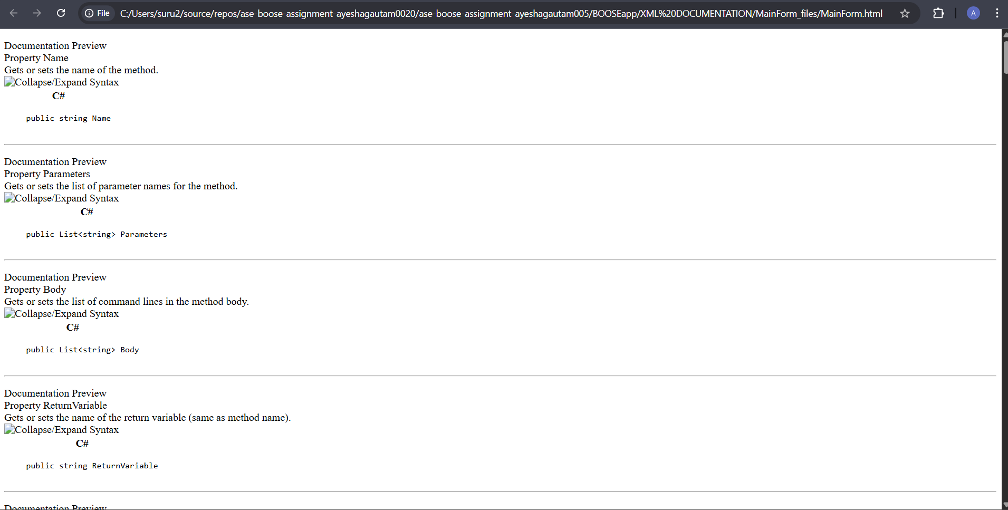
This screenshot shows how the XML comments from the code are displayed in a documentation website.

Factory pattern implementation:
The code used for implementation:

* Test all design patterns
moveto 100,100
pen 0,0,255
circle 150
rect 200,100

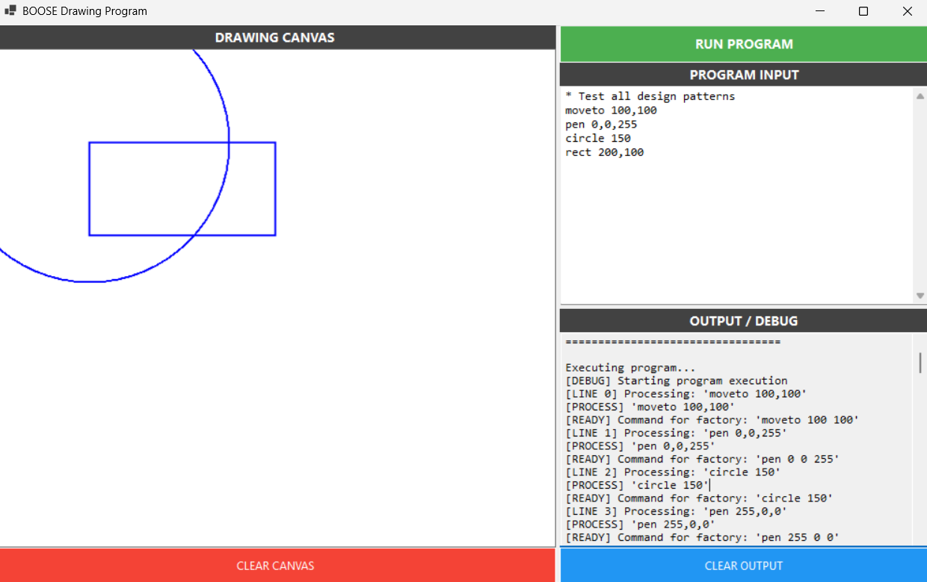
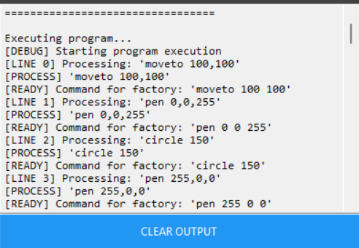

The "READY] lines in the "circle 150" command INPUTs demonstrate the application of the Factory Pattern. So now, each time the command is entered on the input line "circle 150," rather than making an object representing a circle, it refines the command from "circle 150" to be processed by a factory to produce an object representing a "CircleCommand."

Singleton pattern implementation:
The line AppCommandFactory factory = AppCommandFactory.Instance uses the Singleton Pattern.

Replaced Variables:
Types: int (whole numbers) and real (decimal numbers)
Restricted int variable:
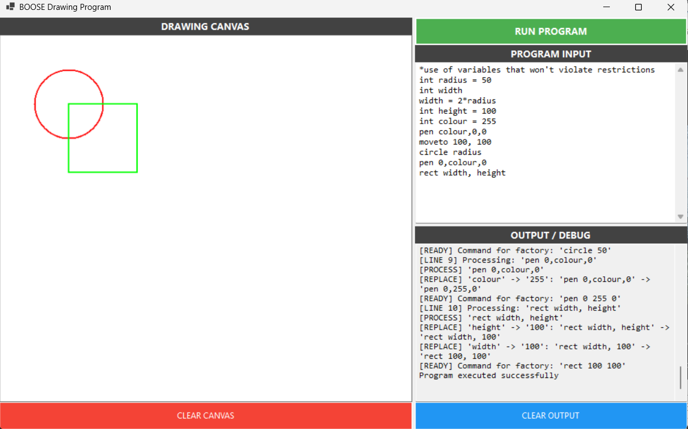
The program implements variables to store and reuse values in drawing commands.

Unrestricted int variable
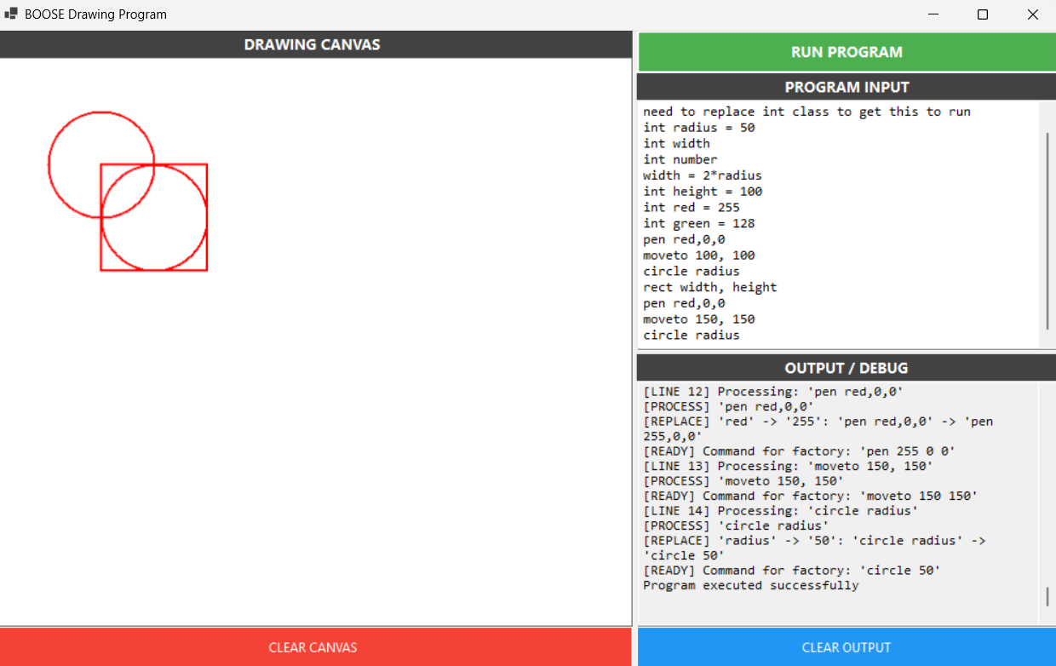
The output shows integer variables successfully storing values, substituting into drawing commands, and evaluating expressions while maintaining type integrity throughout execution.

Restricted reals
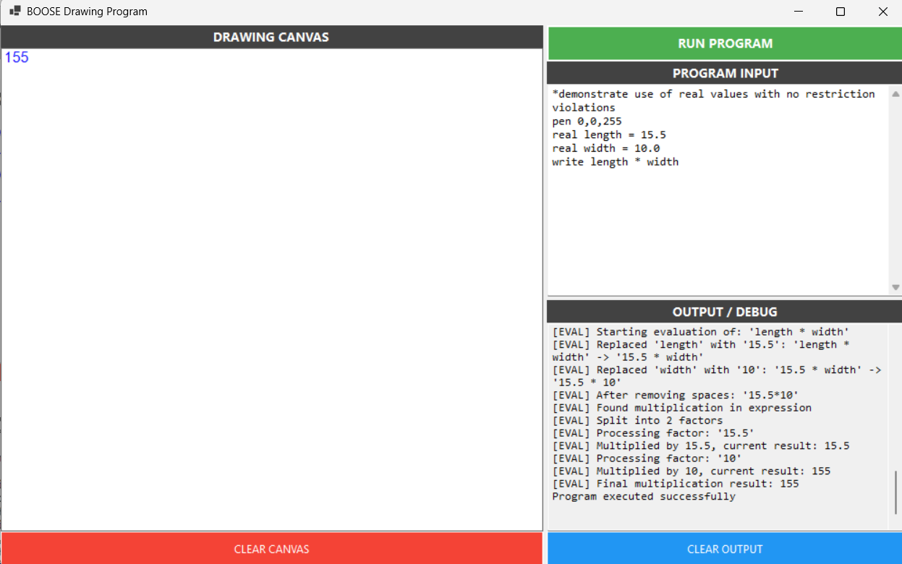
The output shows real variables correctly storing decimal values, evaluating multiplication expressions, and producing accurate floating-point results while maintaining proper type handling.

Unrestricted reals
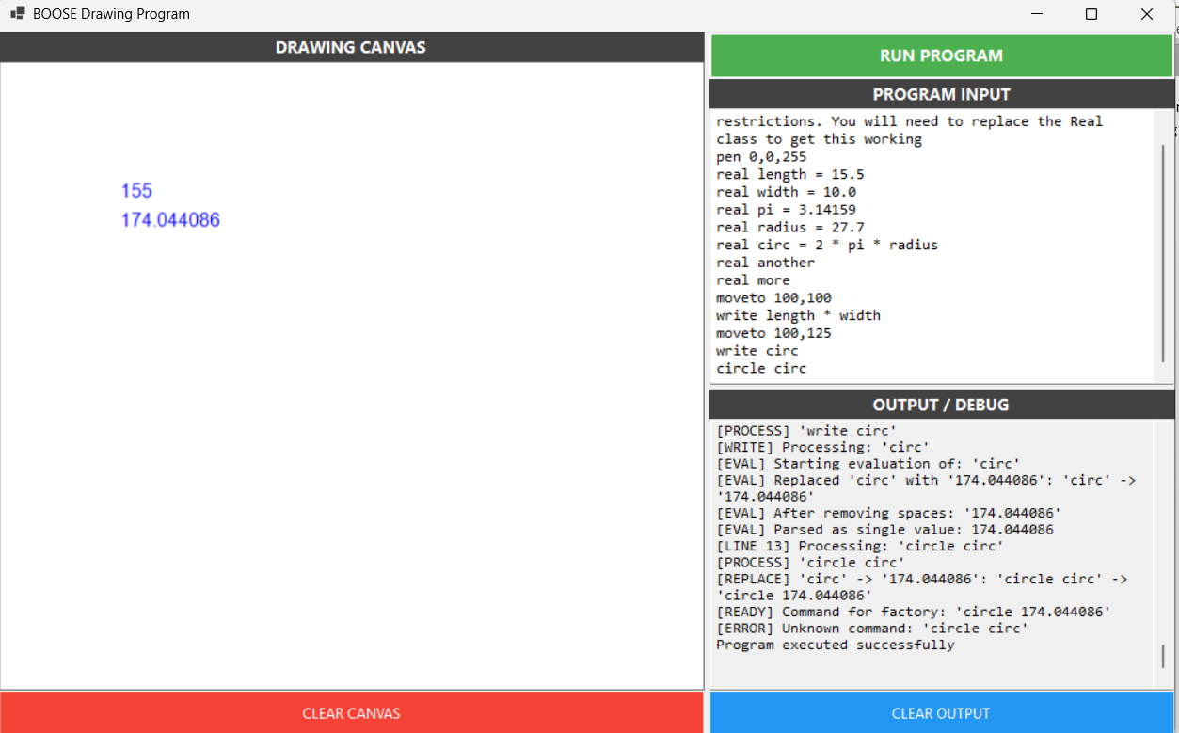
The output demonstrates real variables storing and calculating decimal values accurately.

Restricted array
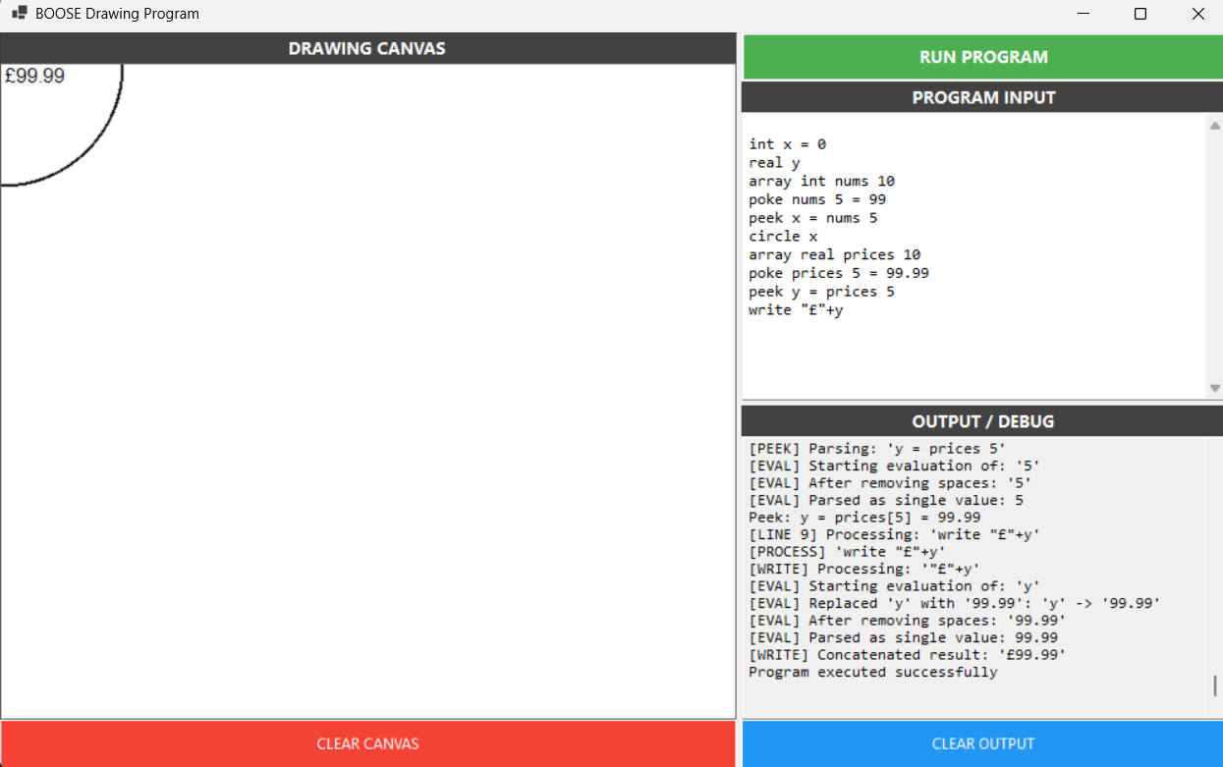
The output demonstrates arrays correctly storing and retrieving both integer and real values

Unrestricted array
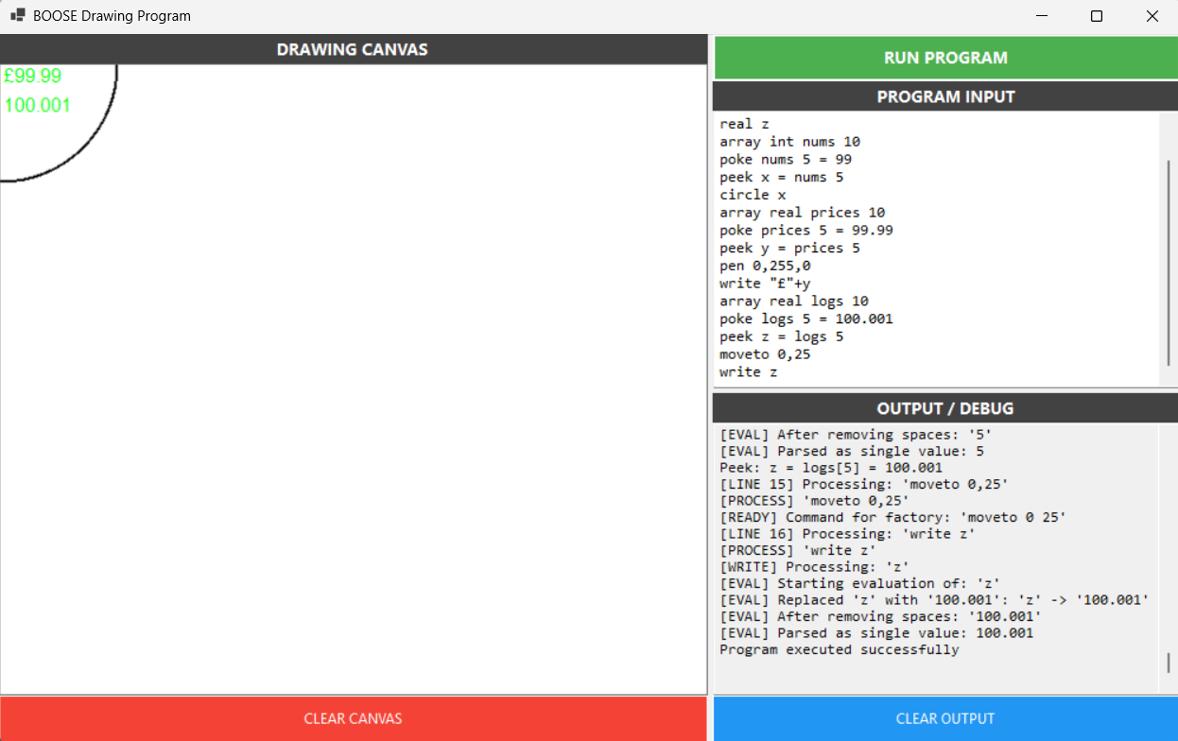
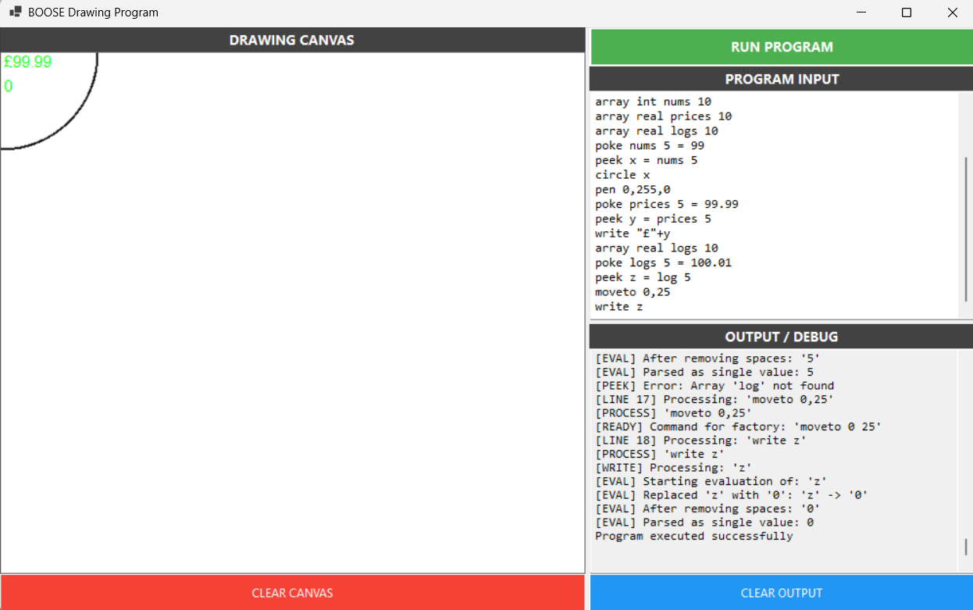
These outputs show arrays successfully storing and retrieving typed values with proper error handling when accessing undefined arrays

Restricted ifs
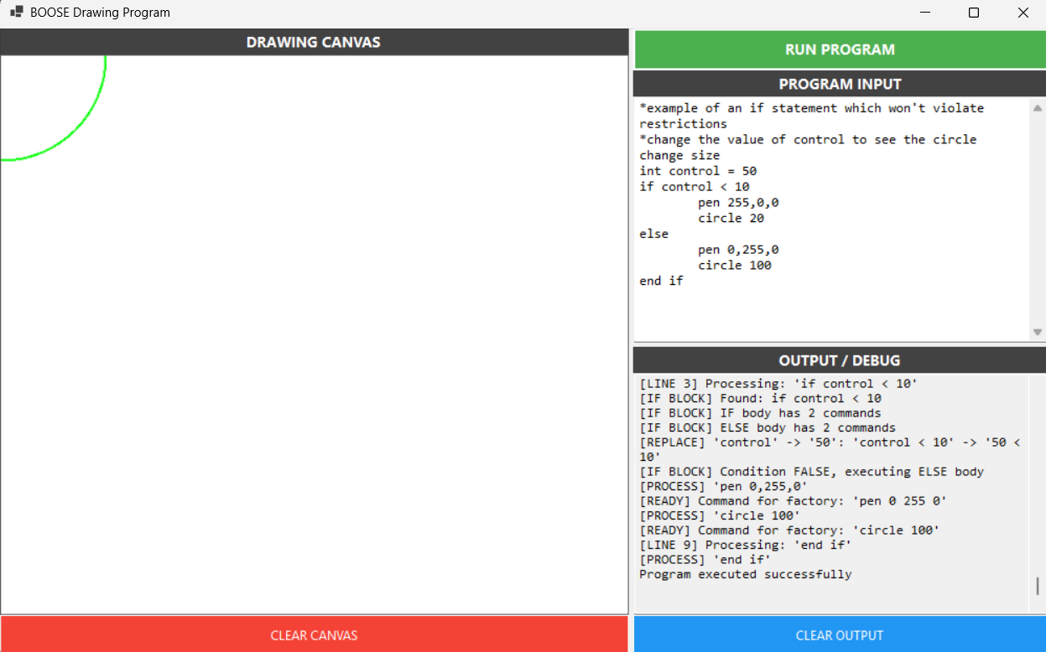

Unrestricted ifs
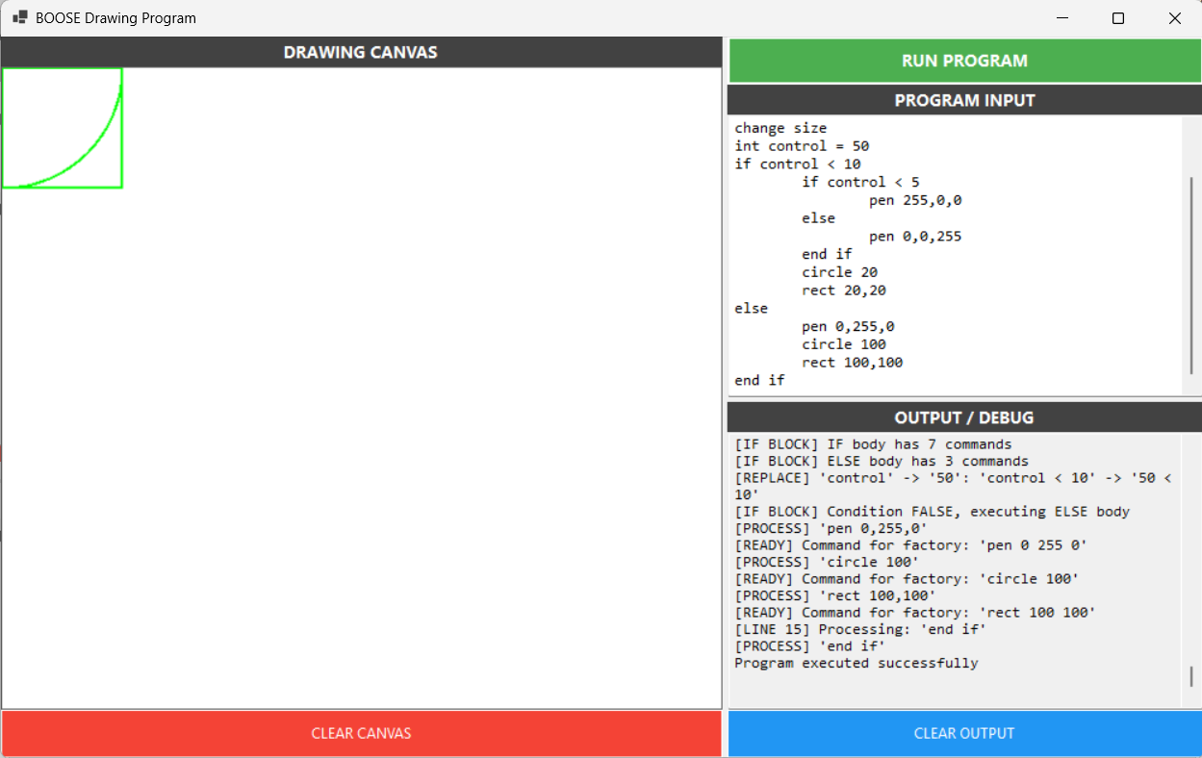

Restricted while
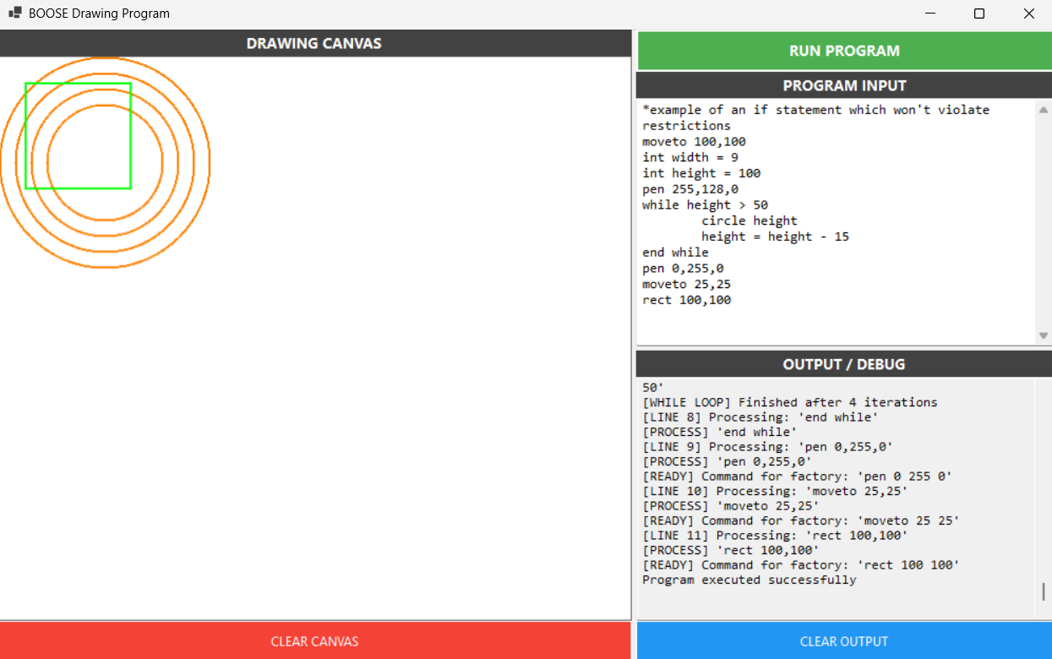

Unrestricted while
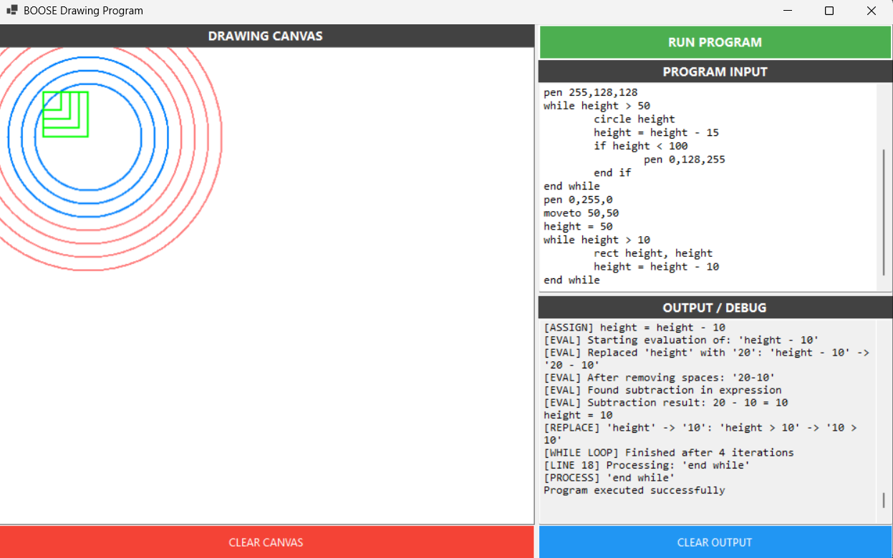Restricted for
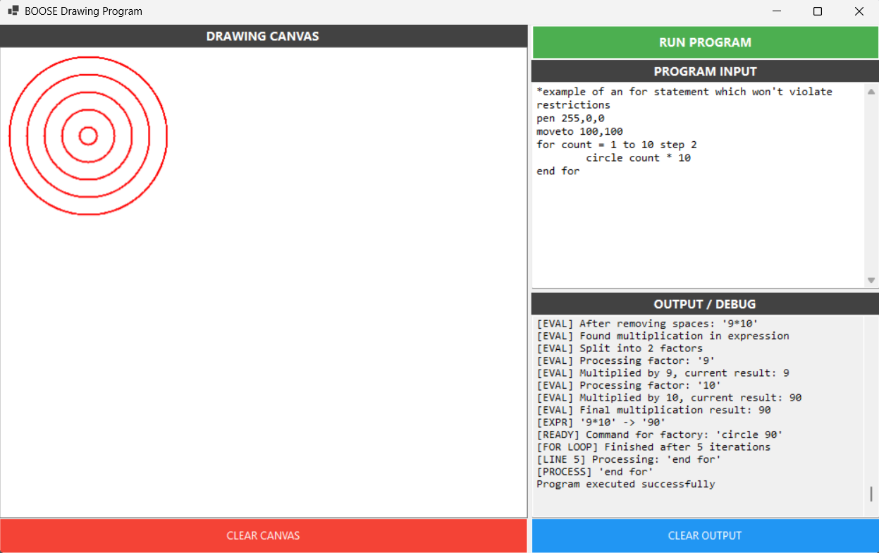

Unrestricted for
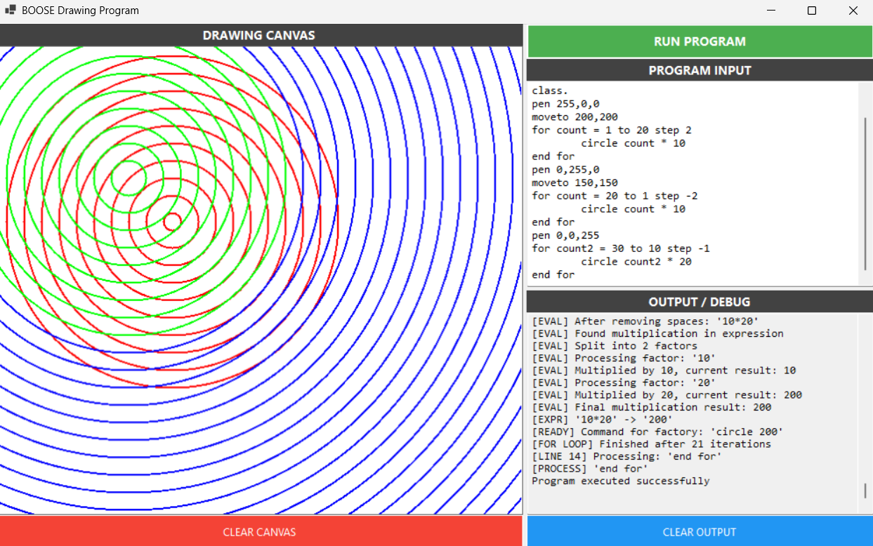

Restricted method
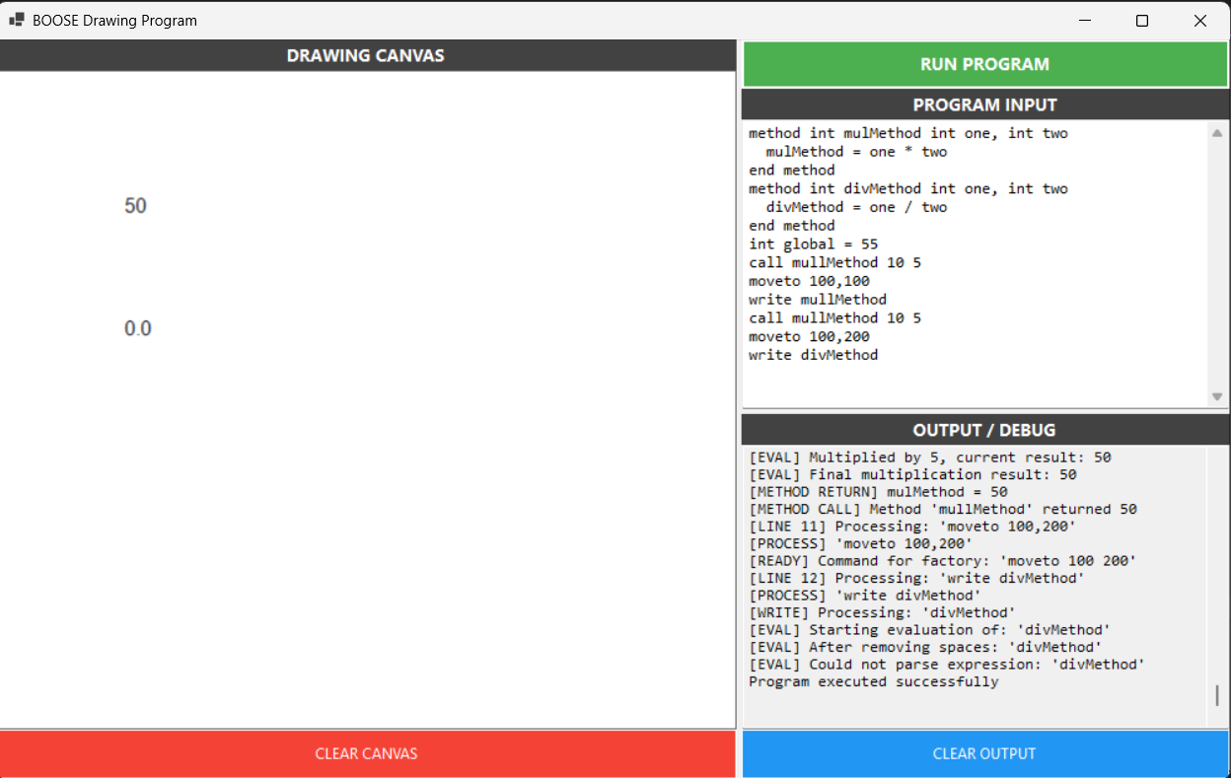

Unrestricted method
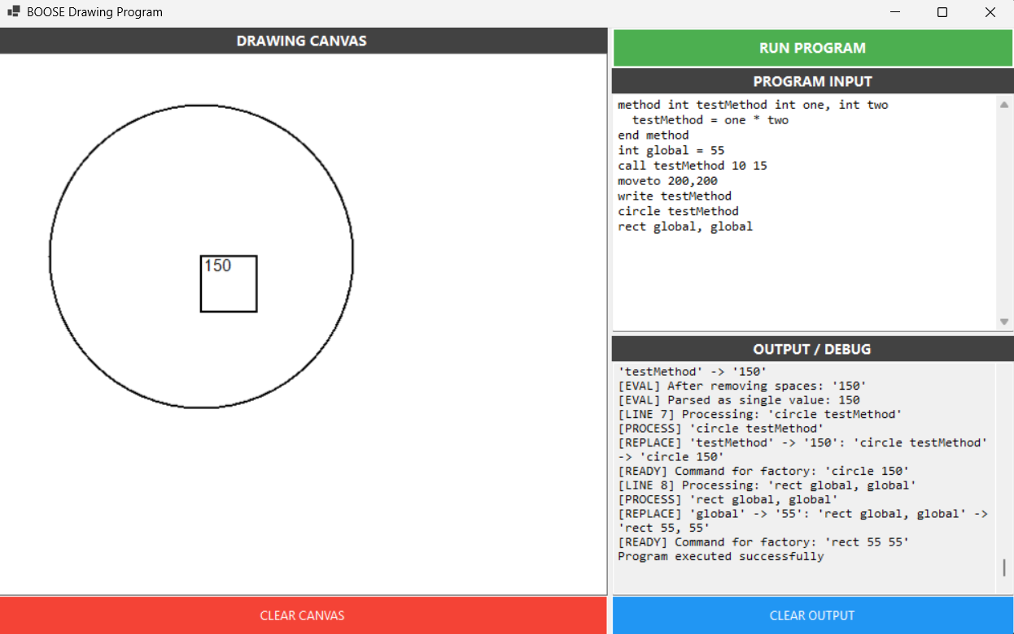
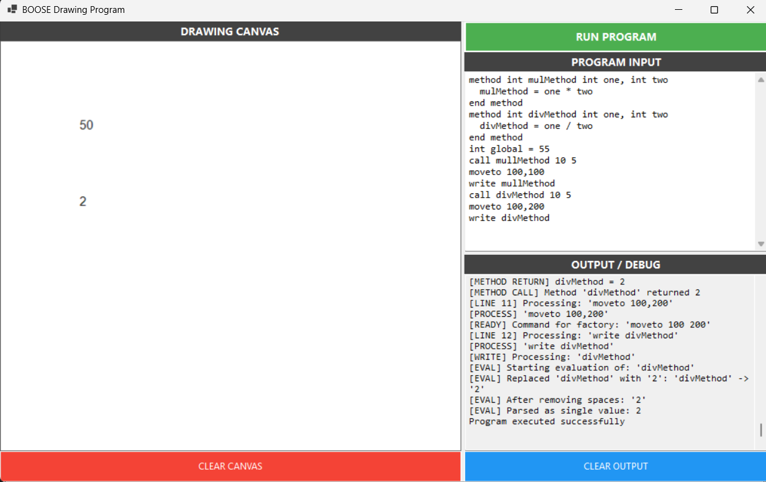

CONCLUSION

My achievements:
The BOOSE Drawing Application has been created successfully and expanded into a feature-rich graphical programming environment that showcases professional software engineering practices. During the assignment phases, the project has transformed from a simple drawing tool to a complex application capable of supporting a complete programming language with variables, arrays, control structures, and user-defined methods.

Learning outcomes:
This project has shown the ability to handle several important software engineering principles:
Design Pattern Application: Practical usage of Factory, Singleton, and Command patterns in the application.
Testing Methodology: All functionality was tested with 19 unit tests, which is a comprehensive test-driven development.
Documentation Practices: Professional XML documentation and user manuals were created.
Error Handling: Custom exception classes were used in robust exception management.
User Interface Design: The Windows Forms interface was designed intuitively with a clear workflow.
Algorithm Implementation: The implementation of expression evaluation, variable management, and control flow processing.

DECLARATION OF GENERATIVE AI USE:
I DID use Generative AI technology in the development, writing, or editing of this assignment. I have included a copy of the reference used, and the output generated in the Appendix section.

Date | Generative tool used | How the tool was used
3/12/2025 | Gemini | Helped me fix some errors on my code
5/12/2025 | Chatgpt | Helped me with my xml comments.
6/12/2025 | Gemini | Helped me with my confusion of xml web based generation
7/12/2025 | Chatgpt | Asked help for documentation (what points should be added)

